### 

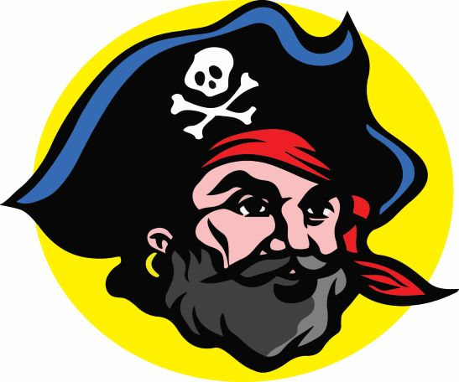

**Pirate Athletic Hall of Fame, Inc.**

**Golf Tournament Dedications**

**1995 - 2022**

**2000 David A. Porter, Class of ‘59**

**2001 Richard L. Jones BCHS 1st Principal**

**2002 Dorothy Sellers, BCHS 1st Dean of Women**

**2003 Coach Ken Robinson**

**2004 Dedicated to The BCHS’s 50th Anniversary**

**2005 Beth Myers Swanson ‘79**

**2006 Dr. Mark Varidan ‘76**

**2007 Dennis Crenshaw BCHS Faculty member**

**2008 Coach Gene Biittner**

**(2009-2013 NO GOLF TOURNAMENTS WERE HELD)**

**2014 Coach Gerry Ramsberger**

**2015 Floyd Lassiter ‘78**

**2016 No tournament dedication**

**2017 Paul Booher, Jr. ‘57**

**2018 Coach Jerry Ruelf**

**2019 Joseph H. Joe Lang ‘55**

**~~2020 Barry Wax ’63~~ (no tournament held Covid 19)**

**2021 Barry Wax ‘63**

**2022 Coach Dan Wickline**